Lab9 - Web Application and Virtual Agent Using Custom Data with Azure OpenAI
Build a Streamlit virtual agent that answers employee questions using HR policy PDFs and Retrieval-Augmented Generation (RAG).
Python | Streamlit | Azure OpenAI | PDF-based RAG

1. Objective
Build and run a local web application that answers employee questions using custom HR policy PDF documents.
By completing this lab, participants will learn how to:
- Configure an Azure OpenAI application using environment variables.
- Extract text from PDF documents and divide it into manageable chunks.
- Generate embeddings and retrieve relevant policy excerpts.
- Use Azure OpenAI to generate answers grounded in retrieved documents.
- Build, test, and troubleshoot a Streamlit-based virtual agent.
Expected outcome: A working local web application that retrieves relevant HR policy content and uses it to answer employee questions without inventing unsupported policies.

2. Project Structure
The project directory should contain the following files and folders.

UC09-AzureOpenAI-VirtualAgent/
app.py
Streamlit application and RAG workflow.
.env.example
Template for Azure OpenAI settings.
.env
Local configuration containing secrets. Never share or commit this file.
requirements.txt
Python package dependencies.
data/
Folder containing HR policy PDF files.

3. Prepare the Project
Complete the following steps before installing dependencies.
Step 1 — Extract the ZIP file
Extract UC09-AzureOpenAI-VirtualAgent.zip into a working folder on your computer.
Step 2 — Create the environment file
Copy .env.example and rename the copy to .env. Place it in the project root, alongside app.py.
Step 3 — Configure Azure OpenAI
Open .env and enter the required Azure OpenAI endpoint, API key, API version, chat deployment name, and embedding deployment name using the variable names expected by the project.
Keep the API key private. Never upload .env to source control or share it publicly.

4. Install Dependencies on Windows
If your computer has Python 3.13.7 but the provided batch launcher expects Python 3.11, use the manual setup below. The Python version must be compatible with the project's dependencies.

Step 1 — Open PowerShell
Navigate to the extracted project folder. Replace the example path with your actual project location.
cd path\to\UC09-AzureOpenAI-VirtualAgent

Step 2 — Create a virtual environment
python -m venv .venv

Step 3 — Activate the virtual environment
.\.venv\Scripts\Activate.ps1

Step 4 — Upgrade pip
python -m pip install --upgrade pip

Step 5 — Install project dependencies
pip install -r requirements.txt

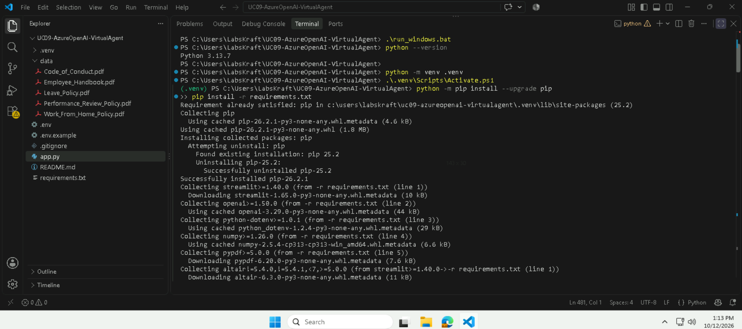Verification checklist
- The virtual environment was created successfully.
- The virtual environment is activated.
- requirements.txt dependencies installed without errors.
- The .env file exists in the project root.

6. Launch the Application
With the virtual environment activated, execute:
python -m streamlit run app.py
- Wait for Streamlit to start.
- Locate the local URL printed in the terminal, commonly http://localhost:8501.
- Open the URL in your web browser.
- Keep the terminal open while using the application.
Expected result
The Streamlit web interface loads successfully, allowing you to upload PDF documents, build the knowledge base, and ask questions about HR policies.

7. Build the PDF Knowledge Base
Step 1 — Add policy documents
Copy HR policy PDFs into the data/ folder before launching the app, or use the application's sidebar upload control. If uploaded files must persist across sessions, ensure they are saved to data/ or another configured persistent location.
Step 2 — Build or refresh the index
Select Build / Refresh Index in the application.
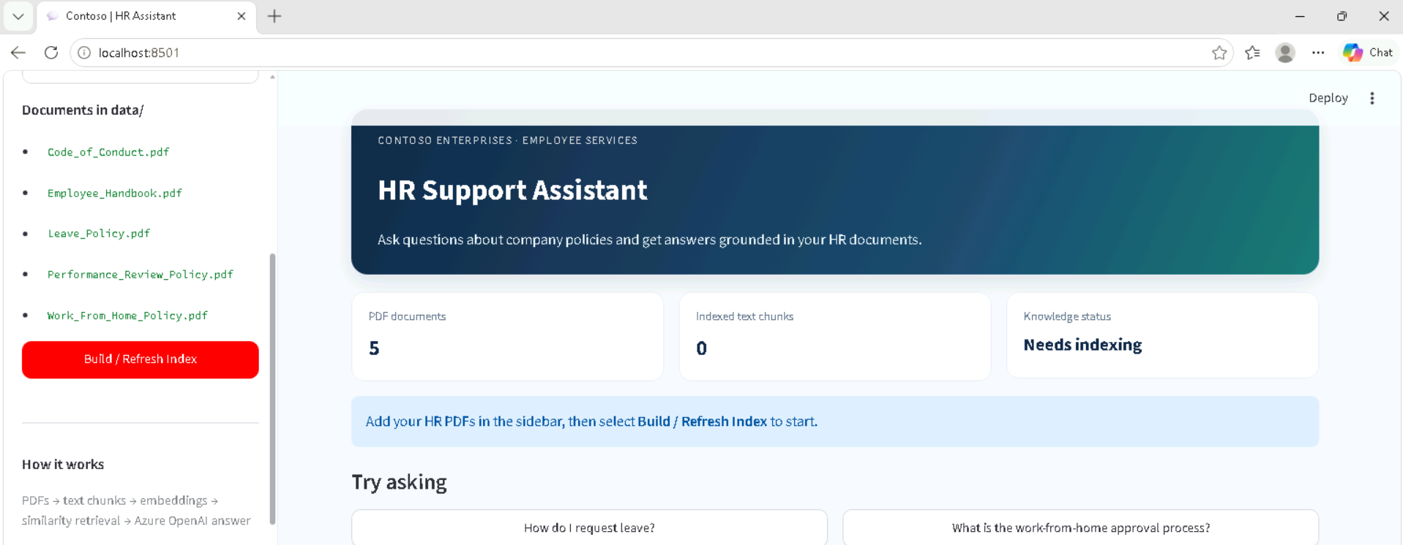The workflow should:
- Extract text from the PDFs.
- Split the extracted text into overlapping chunks.
- Generate embeddings through the Azure OpenAI embedding deployment.
- Create a searchable index in the current Streamlit session.

Step 3 — Validate the index
Confirm that the application reports the expected number of PDF files and indexed text chunks. Resolve extraction or configuration errors before testing questions.

8. Test the Virtual Agent
Ask questions that can be answered from the HR policy documents. Use the following test cases to validate retrieval and response quality.
No. | Test question | What to verify
1 | How many annual PTO days does an employee receive based on years of service? | The answer reflects the applicable leave entitlement.
2 | How far in advance should an employee submit a request for 4–9 days of PTO? | The correct notice period is retrieved.
3 | What should an employee do for an emergency same-day PTO absence? | The required notification or approval procedure is identified.
4 | What are the eligibility requirements for working from home? | The response reflects the documented eligibility criteria.
5 | Which form is required to request a flexible work arrangement? | The correct form or process is identified.
6 | What are the main principles in the Code of Conduct's AI ethics section? | The response summarizes the relevant principles in the source document.
Expected result
The virtual agent should answer using relevant retrieved policy excerpts and identify the corresponding source documents when source attribution is supported by the application.
If the retrieved content does not provide enough information, the agent should state that the answer cannot be confirmed from the available policies and direct the employee to HR rather than inventing a policy.

9. Code Understanding — Key Functions
The following table summarizes the main functions used in app.py.
Function | Purpose
missing_settings() | Checks whether required Azure OpenAI configuration settings are missing.
get_client() | Creates an AzureOpenAI client using the configured endpoint, API key, and API version.
pdf_files() | Finds PDF files stored in the project's data/ folder.
read_pdf(path) | Extracts selectable text from PDF pages and combines the extracted content.
make_chunks(text, source) | Splits document text into overlapping chunks and associates them with the source document.
load_document_chunks() | Reads each PDF and collects its text chunks while recording extraction errors.
create_embeddings(client, texts, deployment) | Converts text chunks into numerical vectors using the Azure OpenAI embedding deployment.
build_index() | Loads PDF chunks, generates embeddings, and returns the searchable chunk collection and vector matrix.
retrieve(question, chunks, matrix) | Embeds the user's question and ranks document chunks using cosine similarity.
generate_answer(question, results) | Sends the question and retrieved policy excerpts to the chat deployment to generate a grounded response.
save_uploaded_pdfs(uploaded_files) | Saves PDFs uploaded through the Streamlit interface into data/.
index_signature() | Computes a signature from PDF filenames, sizes, and modification times to help detect document changes.

10. Application Workflow
The application follows a Retrieval-Augmented Generation (RAG) pipeline.
1. Upload or copy PDF documents
save_uploaded_pdfs() or data/ folder
2. Extract PDF text
read_pdf()
3. Split text into chunks
make_chunks() and load_document_chunks()
4. Generate embeddings and build index
create_embeddings() and build_index()

5. Employee asks a question
6. Retrieve relevant excerpts
retrieve() ranks chunks by similarity
7. Generate a policy-grounded answer
generate_answer() calls Azure OpenAI

8. Display the answer and source references
The employee receives an answer based on the retrieved policy content.
Key concept: Embeddings represent text as numerical vectors. Retrieval uses these vectors to find relevant content, while the chat model uses the retrieved content to formulate the answer.

